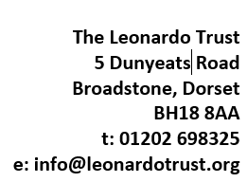
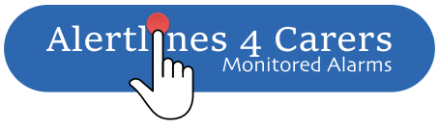

Office use only
Date Received:
Unpaid Carer Referral Form
Agency details:
Your Name & Job Title
Agency Name
Agency Address
Contact Numbers: |  | Email:
Cared for details:
Name of Cared for:
Address of Cared for:
Postcode:
Contact Numbers:
Date of Birth:
Carer details:
Name of Carer:
Relationship:
Address of Carer:
(If different from above)
 |  |  | Postcode:
Contact Numbers:
Date of Birth: |  | How long have they been a carer?
Information about the grant you are applying for:
Working in partnership with Connected Living we are offering FREE installation and the first FOUR MONTHS FREE for Connected Living–At Home/Locate Package. This will include a monitored Home Alarm and Pendant or GPS Locator. Connected Living will undertake an assessment with the customer and Carer during the installation. Further funding may be available from The Leonardo Trust for an extended service, additional equipment or a keysafe if required.

Please tell us how a monitored home alarm would help the carer?

The Leonardo Trust: I understand that all information supplied on this application form to Leonardo Trust will be kept strictly confidential and will only be used for the purpose of selection and administration. The information I have given in this application is, to the best of my knowledge, true and accurate. I accept that any false or misleading statements may be sufficient cause for rejecting an application. A copy of our Grant Making Policy is available on our website, www.leonardotrust.org or alternatively from our Broadstone office.

Connected Living: I understand that if funding has been agreed, this information will be shared with Connected Living who will carry out the installation and store my information in accordance with Data Protection Law. More details can be found on our website: www.aster.co.uk/privacy.

The trustees regret we are unable to reimburse costs already paid or anything that has been booked, contracted for, or reserved prior to our agreement to fund/part-fund the cost.

Signature of Professional (Connected Living): |  | Date:
Signature of Unpaid Carer: |  | Date:

Connected Living – Office Use:

Connected Living - Technician Assessment/Office Request:
Package Required:
Additional Equipment Required:
(for example, additional pendant, fall detector etc)
One-off purchases required to be considered for funding?
(for example, keysafe, keysafe type)
What is the reason for this additional requirement? (Please state)
Would the customer like to know more about Benefit help from The Leonardo Trust advisor? | YES / NO If yes, The Leonardo Trust will be in touch.
Signed on behalf of Connected Living: |  | Date

Leonardo Office Use:

Length of Funding:
(4 months free or for an extended duration)
Funding agreed and signed on behalf of:  THE LEONARDO TRUST |  | Date:
Print Name:

Please send completed form to: ConnectedLiving@Aster.co.uk
Jenny.Wells@Aster.co.uk

Copy to: Tina.Adams@Aster.co.uk

